VR Developer Nanodegree Program Capstone Project

Mobile Performance & 360 Media Specialization

Borbala Menyhart

2018

Pre-production brainstorm 2

Pre-Production and Scope Reduction 3

Fundamentals 3

Completeness 5

Challenges 6

Game Description: 7

3D models: 8

Photogrammetry : 9

Gamification: 10

Spatial audio  / Resonance Audio 10

Game Loop 11

Target platform: 12

Speech Recognition / User permission: 12

Play Store: 13

PRESENTATION VIDEO: <https://youtu.be/gfW82rSp870>

Pre-production brainstorm

Based on the project requirements, the achievement categories I have to accomplish, and the provided theme (Emotion), I decided to make a game.

Playing a game is always fun. My selected emotion is Joy.

People usually like ballgames, so playing something with a ball or balloon will be my basic concept.

My goal is to build a Daydream mini-game that I can publish on Google Play store under my developer account (AndroCats) as well.

Pre-Production and Scope Reduction

(First assessment what I need to build to complete the requirements and revisions during the development process)

Fundamentals

### **Checkmark1. Scale achievement (100 points)**

My player should feel about human height.

**Revised**: I will place the camera about 1.7-meter high, so that will do the trick. The props will be scaled based on this height.

User test: The scaling is perfect. The propeller was too far. I placed it closer to the player.

**2. Animation achievement (100 points)**

This game will be a ballgame, so there will be animation in the game.

**Revised**: Some of the hoops will be animated, and the UI button will be animated, too.

If the balloon touches the ground, it will burst.

### **3. Lighting achievement (100 points)**

I will use baked lighting to secure the best mobile performance.

### Close**4. Locomotion achievement (100 points)**

There will be no player motion in the game. The player will stay in place and play with the controller.

### **Checkmark5.** **Physics achievement (100 points)**

This game will be a ballgame, so there will be Physics in the game.

**Revised**: I chose balloons instead. The balloon will be moved by force, based on the user input with the controller and the phone step detector sensor.

*User test: The balloon can go too high. I maximized it.*

#### **Checkmark6. Video Player achievement (100 points) (2x if Lighting achievement is also completed)**

At the beginning of the game, I can show video instructions. (Better than reading)

**Revised**: I will show video instructions about how to use the Daydream controller to maneuver the balloon.

*User test: The User liked the video instructions very much.*

### 

### Magnifying glass**7. Empathy achievement (100 points)**

If I can use voice ordering in my game than my player would be able to play without using his/her hands. That would be nice for disabled people.

**Revised:** Unfortunately, listening continuously for voice ordering is not possible on Android.

**My estimation is 600 points in this category.**

Completeness

**1. Gamification achievement (250 points)**

The player will gather scores. Save score?

**Revised:** In the Player Prefs I can save some game data, so there will be an opportunity to save high scores and players’ name in the game.

*User Test: User asked indication if the high score was beaten. I added sound effects and colors to the UI.*

**2. Diegetic UI achievement (250 points)**

In the intro scene, there will be some info about the game and how to use the controller.

**Revised**: I will show video instructions about how to use the Daydream controller.

In the Game scene, there will be no further instruction.

*User test: The User liked the video instructions very much.*

**3. Alternative Storyline achievement (250 points)**

Different game modes will provide alternate storyline.

**Revised:** There will be two modes to choose from: Three balloons or Timer mode.



**4. AI achievement (250 points)**

----

**5. 3D Modeling achievement (250 points)**

I used Blender before, so I can build the props for my game.

**Revised:** I used very basic shapes in Blender and built my own hoop models.

**6. Photogrammetry achievement (250 points)**

I will do further research, but as far as I know, there is a technique with which it is possible to build a 3D object based on only one photo. Adobe Illustrator and Blender will be necessary.

**Revised**: I was able to trace the image in Adobe Illustrator and based on the created SVG file I built the model in Blender. This was a bit time-consuming method. The other models will be made with Blender only.

**My estimation is more than 1000 points in this category.**

Challenges

**1. Speech Recognition achievement (500 points)**

I will make a research how to do this.

**Revised: **There will be one point in my game where I can use a microphone for input, when my player input his/her name. I will do this for achievement points only.

From the Google Play version of the game, I will delete this function, because it is not necessary for the game, but It would require user permission and Privacy Policy attachment.

*User Test: Only English words and names were recognized. That is a limitation, the user can use the keyboard as well.*

**2. User Testing achievement (250 points) (2x if you completed 750 points in Completeness)** I will test continuously, and I will involve plus one person in the tests.

**3. Compute Shader achievement (500 points)**

 I do not have any knowledge about shader programming. Unfortunately, I have a very short amount of time working on this project. I do not have enough time for learning this.

**4. Multiplayer achievement (500 points)**

This will be a single player game.

**5. Mixed Reality Video achievement (500 points)**

I do not have resources for this.

**6. App Store achievement (1000 points)**

I will go for this.

**Revised:** I am afraid it will not be possible to design, make models, write scripts, test, publish and gather 100 downloads in this short period of time given to this project. I will ask for extension.

**My estimation is more than 1000 points in this category.**

Game Description:

There will be four scenes in the game.

In the beginning, on the Intro scene, I will show video instructions about how to use the Daydream controller, and I will explain the goal of the game.

I will build a playground, where the player will navigate a balloon through hoops and gather points.

Some of the hoops will move for challenge.

There will be two modes to choose from: Three balloons or Timer mode.

In three balloon modes, the player has three lives, in this case, balloons. If the balloon touches the ground, it will burst.

In the Timer mode, the player has 60 seconds to score as many points as he/she can.

I will build a very relaxing and pleasant environment. My target emotion is joy. Nice music will play in the background.



3D models:

The hoops will be modeled based on an old game called Mindflex Duel Game.

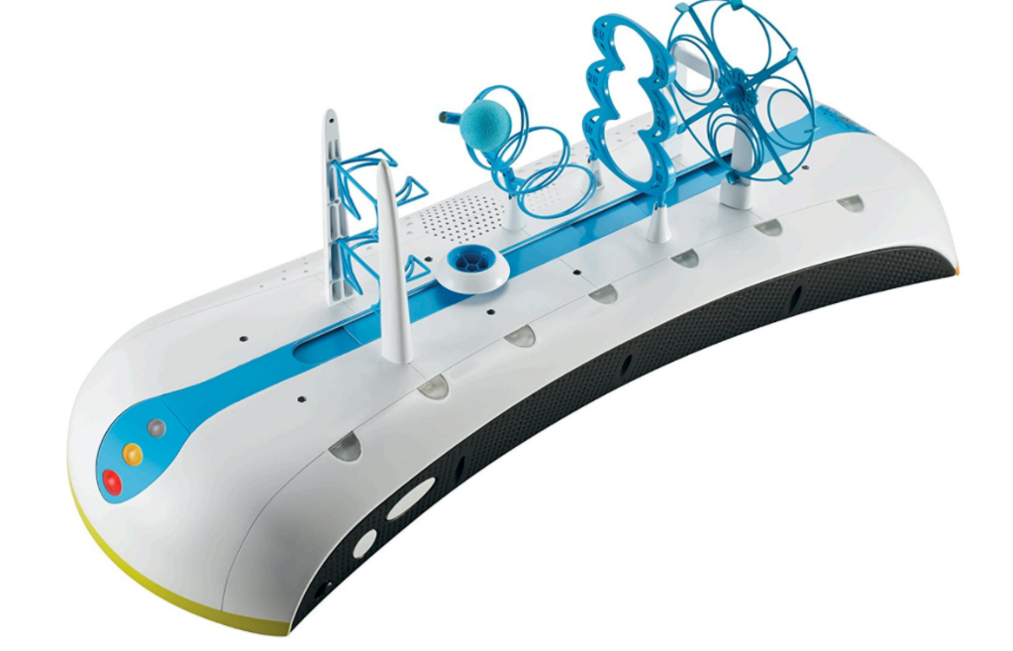

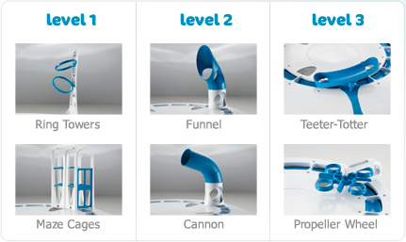

Photogrammetry :

I will use this image to create my own custom model using Adobe Illustrator and Blender. I traced the image in Adobe Illustrator and based on the created SVG file I built the model in Blender.

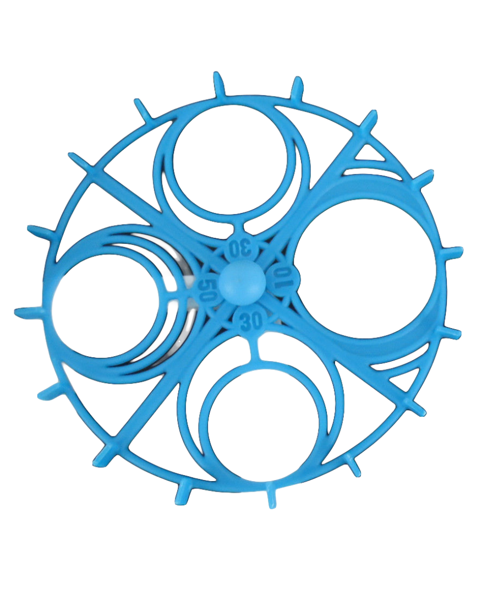

Gamification:

Player gathers points. He/she can save his/her name if he/she beat the high score.

**A hint of challenge will be added:**

To maneuver the balloons through the hoops the player must synchronize three different movements.

Swipe his/her finger on the touchpad to move the balloon forward and backward. Move the controller left and right for horizontal navigation and jog a few steps in place to move the balloon up.

**Effects:**

I will use particle systems, sound effects, and animations for immersive experience.

Spatial audio  / Resonance Audio

# **Spatial audio is deprecated. I will use the new** Resonance Audio instead.

<https://developers.google.com/resonance-audio/develop/unity/getting-started>

Game Loop

1.   The game starts on the Intro scene. Here the player finds information about the goal of the game and how to navigate the balloon through the hoops.

2.    Game scene. The player here can choose which mode he/she desires to play and start playing. That will be the Alternative Storyline.

3.     Game scene. When the game is over, the player will see the high score info and his/her scores as well on the score UI. If the high score was made, the player can save his/her name.

4.  If the player saves his/her name the game loads the Data Entry scene. Here the player can input his/her name with a keyboard or with voice input.

5. Game scene. After the player closes the score UI, he/she can select the game mode and start a new game.

Target platform:

My target platform is Google Daydream.

Daydream ready phone with Android SDK 7.0 and up.

Speech Recognition / User permission:

When the player saves his/her name, he/she can use voice input.

For voice input, the game needs user permission to use the microphone and record audio.

The player will be asked if he/she wants to grant this permission or not.

I will follow Android developer guide. <https://developer.android.com/guide/topics/permissions/index.html>

Play Store:

I published the game on the Google Play under my AndoCats developer account. The Google Play Team accepted it into the Daydream program on Google Play.

My developer website: [androcats.com](http://androcats.com/)

The game promo video: <https://youtu.be/2y5YS1qM97E>

Google Play link: <https://play.google.com/store/apps/details?id=com.androcats.HoopTheBalloon>

